Part Number: PT747-35160

Kit Contents
Item # | Quantity Reqd. | Description
1 | 2 | Protector, Front Door Sill
2 | 2 | Protector, Rear Door Sill
Hardware Bag Contents
Item # | Quantity Reqd. | Description
1
Additional Items Required For Installation
Item # | Quantity Reqd. | Description
1
Conflicts
Recommended Tools
Personal & Vehicle Protection | Notes
None
Special Tools | Notes
Felt block | Felt Block (3M) P/N 71606
Surface Thermometer | Infrared Non-contact
Heat Gun | Master Heat Gun HG-301A or equivalent
Installation Tools | Notes
Lint Free Rags
Special Chemicals | Notes
Cleaner | VDC approved cleaner and cleaning method
General Applicability
Recommended Sequence of Application
Item # | Accessory
1
*Mandatory

Vehicle Service Parts (may be required for reassembly)
Item # | Quantity Reqd. | Description
1
Legend
STOP: Damage to the vehicle may occur. Do not proceed until process has been complied with.
OPERATOR SAFETY: Use caution to avoid risk of injury.
CAUTION: A process that must be carefully observed in order to reduce the risk of damage to the accessory/vehicle and to ensure a quality installation.
TOOLS & EQUIPMENT: Used in Figures calls out the specific tools and equipment recommended for this process.
REVISION MARK: This mark highlights a change in installation with respect to previous issue.
SAFETY TORQUE: This mark indicates that torque is related to safety.

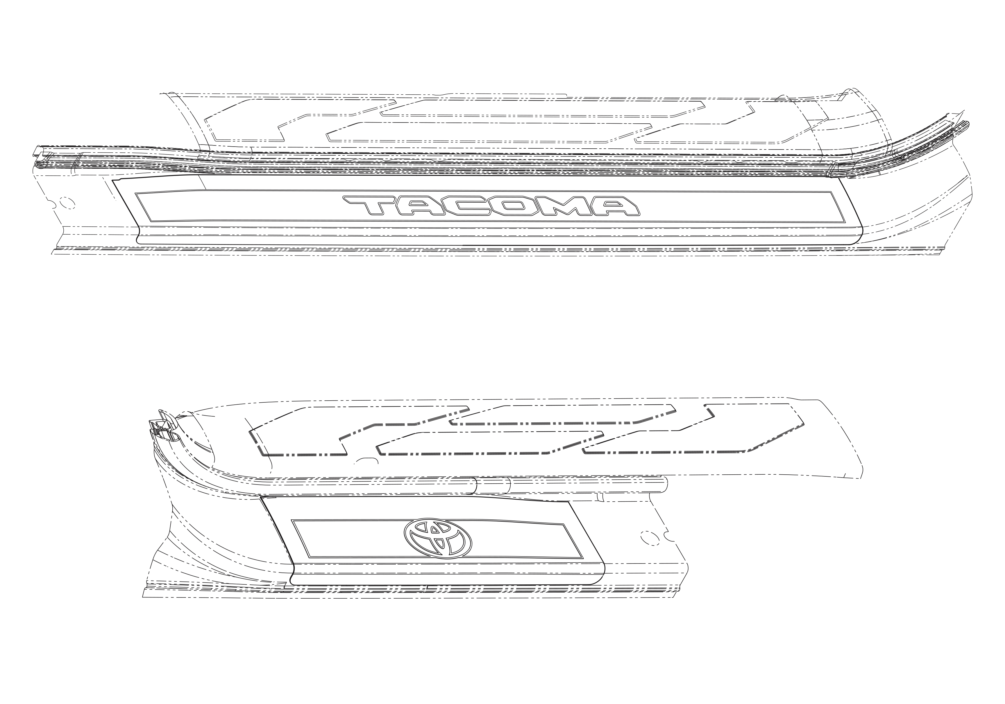
REAR SILL RH
FRONT SILL RH

Care must be taken when installing this accessory to ensure damage does not occur to the vehicle. The installation of this accessory should follow approved guidelines to ensure a quality installation.

These guidelines can be found in the "Accessory
Installation Practices" document.

This document covers such items as:-
• Vehicle Protection (use of covers and blankets, cleaning chemicals, etc.).
• Safety (eye protection, rechecking torque procedure, etc.).
• Vehicle Disassembly/Reassembly (panel removal, part storage, etc.).
• Electrical Component Disassembly/Reassembly (battery disconnection, connector removal, etc.).

Please see your Toyota dealer for a copy of this document.

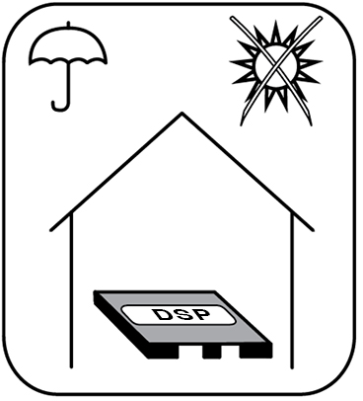  STORAGE | 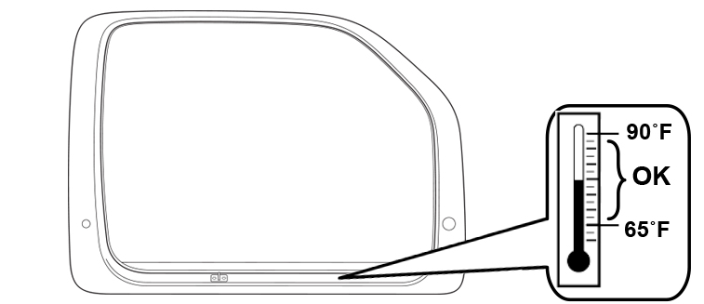  INSTALLATION TEMPERATURE | 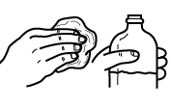  CLEANER
 |  | 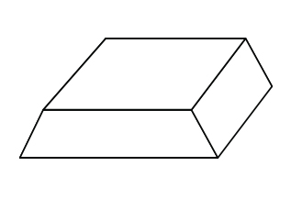  FELT BLOCK | SQUEEGEE  (OPTIONAL) | 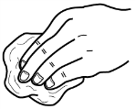  LINT FREE
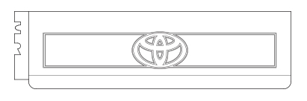
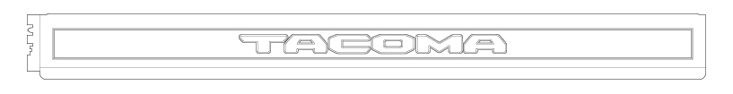

FRONT DOOR SILL PROTECTOR REAR DOOR SILL PROTECTOR

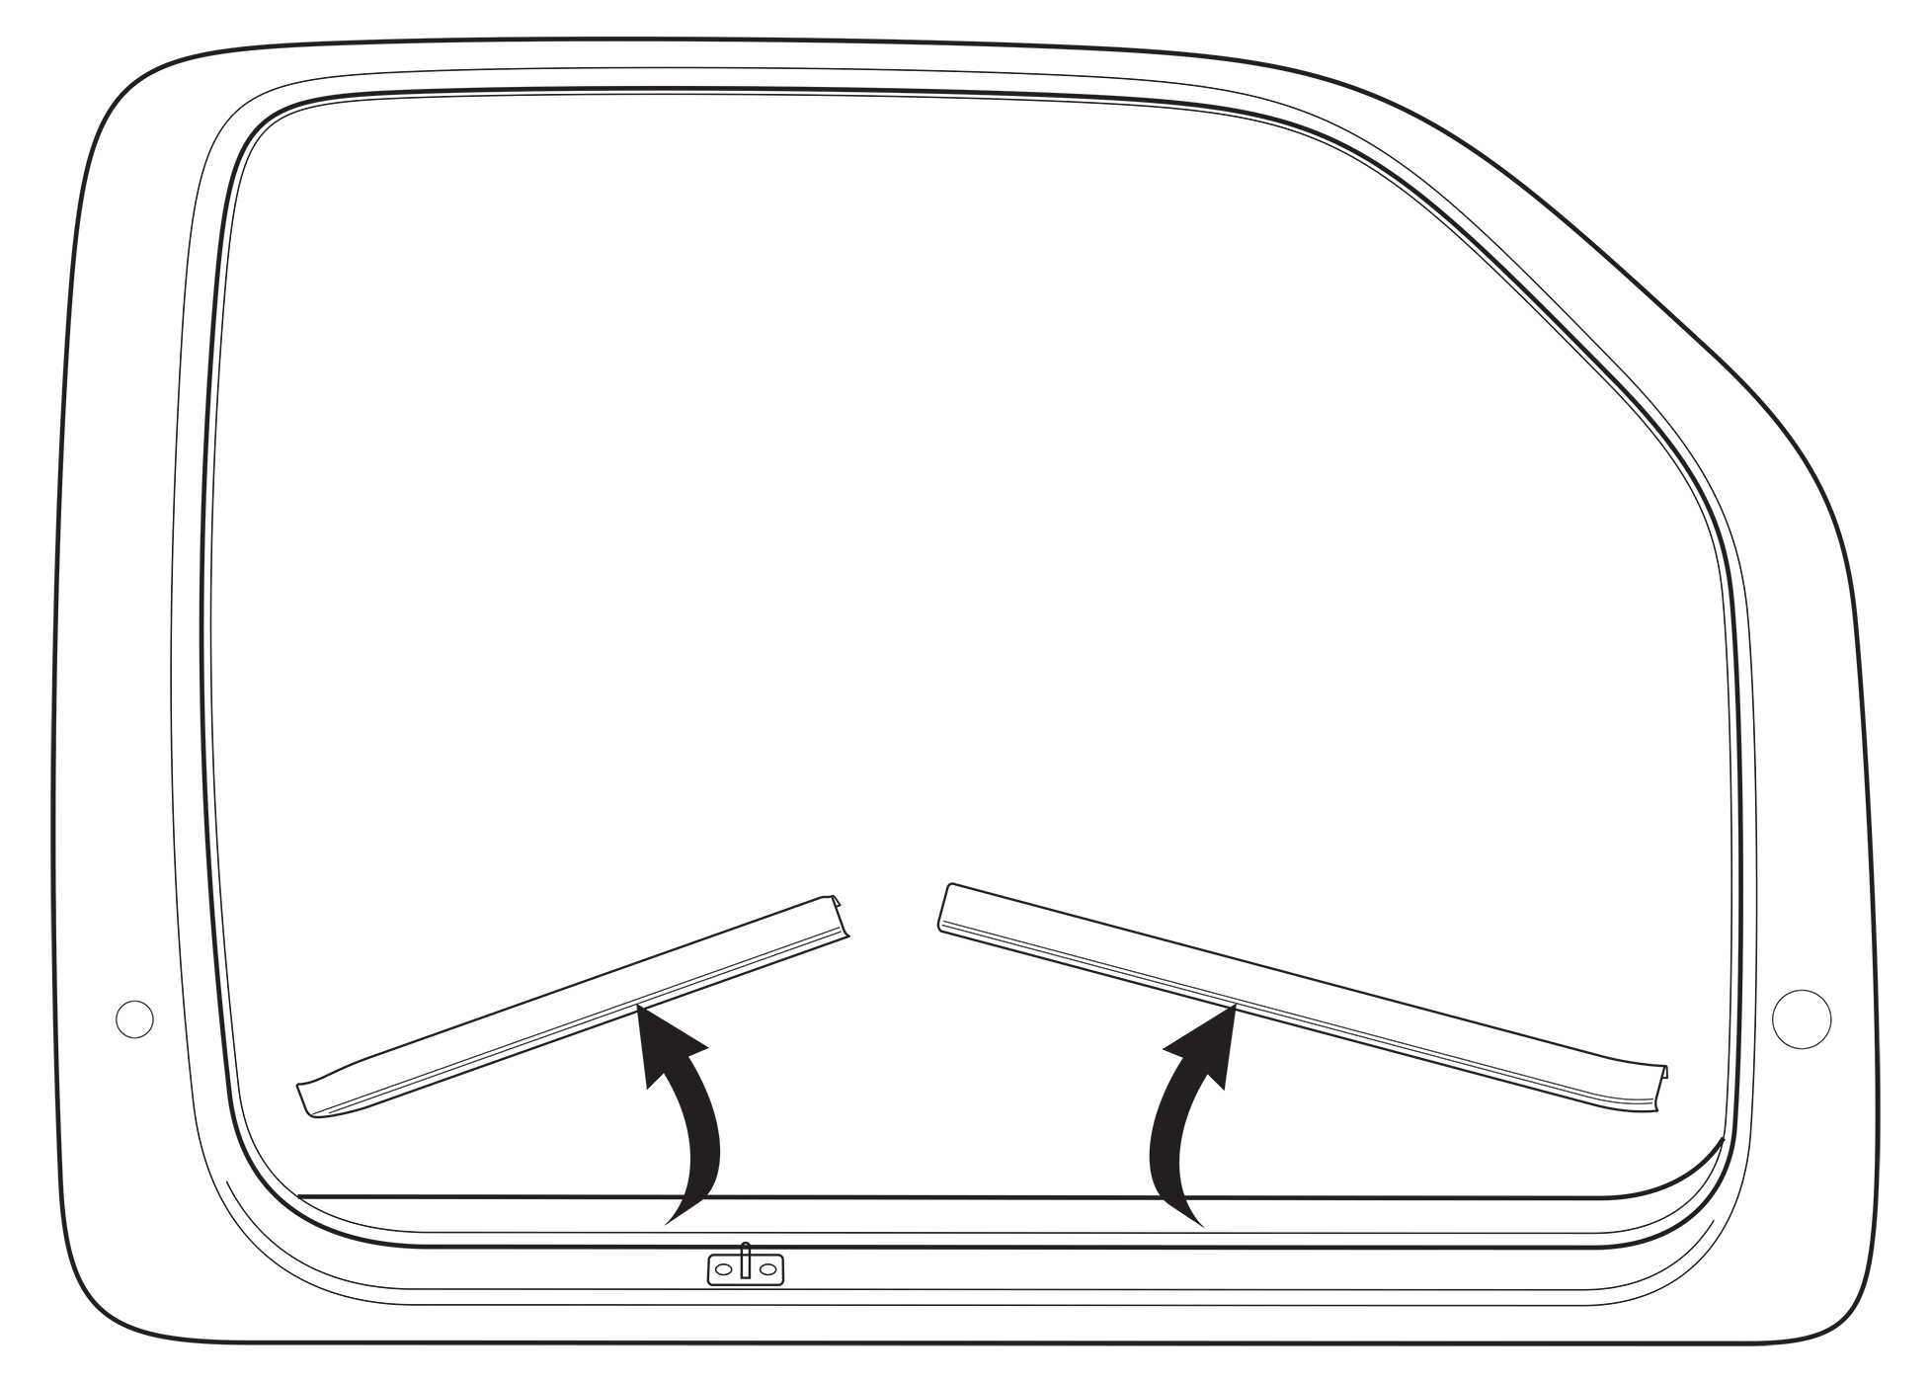
1

Rear
Front

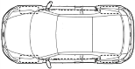

Remove the OE Door Scuff Plates & Weather Strip

3
2
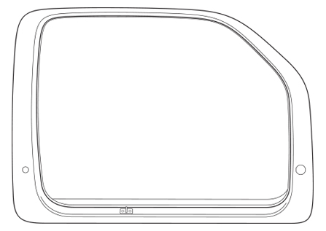

DRY
DRY
REMOVE LINER
b
CLEAN
CLEAN
a

*Zoomed In
4
Starting Edge
Rear
Front
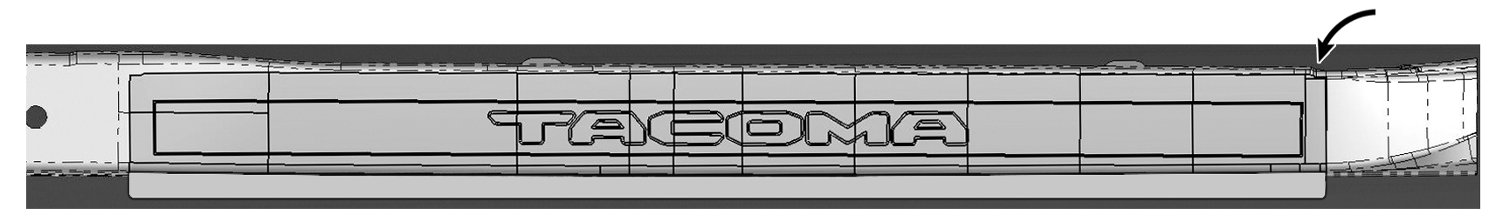

ALIGN

Front
Rear
5

ALIGN

Starting Edge
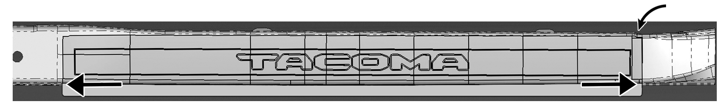

Align the smooth area of the Sill Protector along the door edge

FELT BLOCK

6

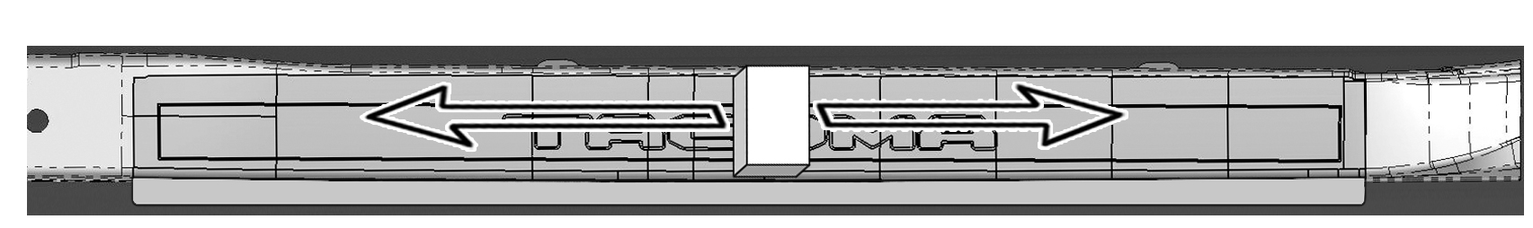

Stroke the felt block back and forth with a consistent force to ensure full adhesion and that air bubbles are not present

7
*Zoomed In

WRAP EDGE

Stroke the felt block back and forth with a consistent force to ensure full adhesion of the door edge portion and that air bubbles are not present

8
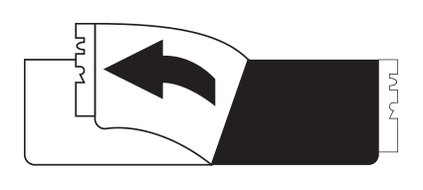
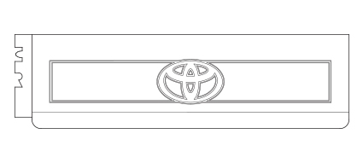
REMOVE LINER
Rear Sill

Front
Rear
9

ALIGN

*Zoomed In
Starting Edge

Rear
Front
10
Align smooth area of Sill Protector along door edge

ALIGN

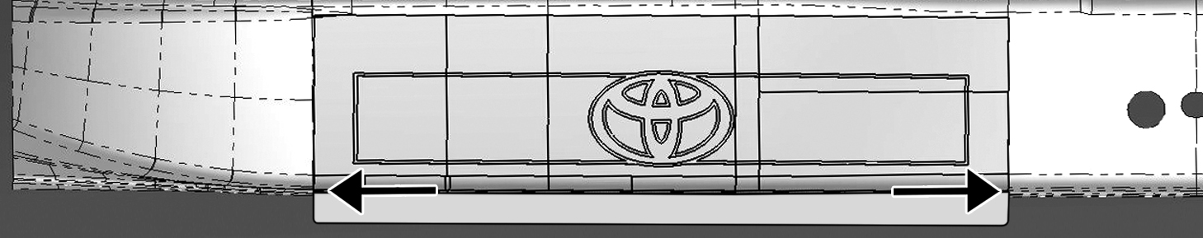

11

FELT BLOCK

Stroke the felt block back and forth with consistent force to ensure full adhesion and that air bubbles are not present.

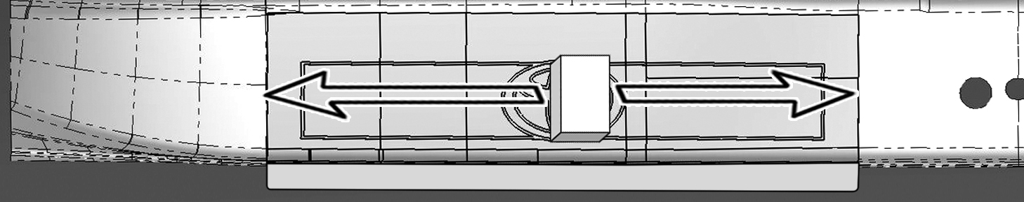

12

FELT BLOCK

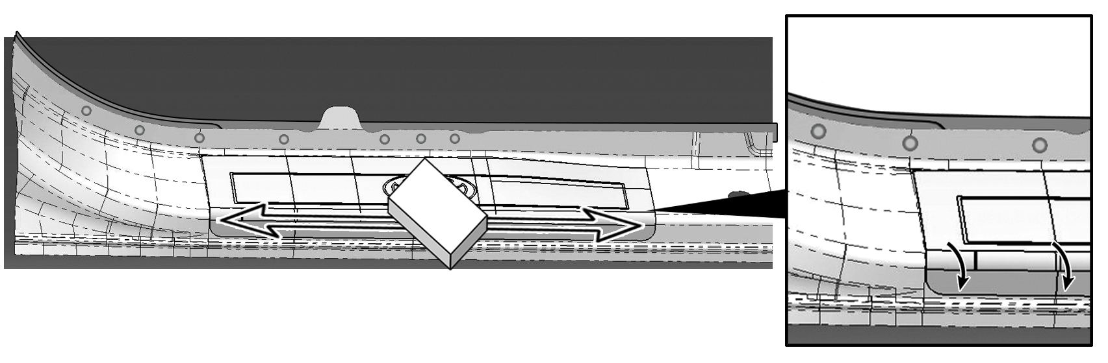
Stroke the felt block back and forth with consistent force to ensure full adhesion of door edge portion and that air bubbles are not present.
WRAP EDGE

*Zoomed In

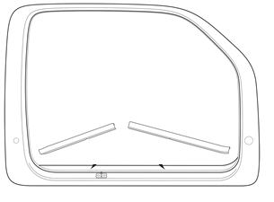
13

Reinstall the Door Scuff Plates

11
12
Accessory Function Checks

Proper adhesion – Visual
Proper adhesion – Physical

Proper alignment – Cross-Car

Vehicle Appearance Check
After accessory installation and removal of protective cover(s), perform a visual inspection.

Look for bubbles, loose and lifting edges.

With light pressure rub hand over top of part and if crackling sound occurs, re-squeegee. If bubbles cannot be worked out to the nearest edge, replace part.

Parts must wrap evenly over the vertical surface.

Ensure no damage (including scuffs and scratches) was caused to the door sill or scuff plates during the installation process.
(For PPO installations, refer to TMS Accessory Quality Shipping Standard.)

